**5. Porter Stemmer Algorithm for Stemming**

**Aim:**  
To perform stemming using the Porter Stemmer algorithm.

**Algorithm:**

1. Import the PorterStemmer from NLTK.
2. Define a list of words.
3. Apply the PorterStemmer to each word.
4. Display the stemmed words.

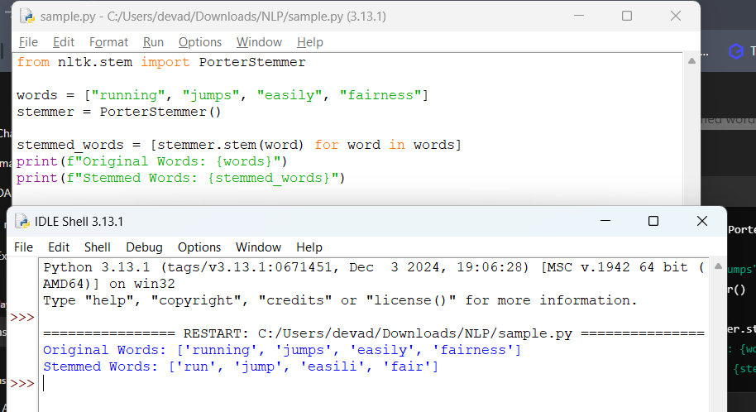

**Result:**  
The Porter Stemmer effectively reduces words to their root forms.